Real World Forays in the Introductory Finance Course

Alva Wright Butcher, University of Puget Sound

ABSTRACT
Most students enter the introductory finance class with a very limited experience with financial markets, financial terms, the financial press, or even an inkling of their own level of risk tolerance. Some students actually dread the introductory finance class because of the quantitative nature of the topics. But for all students, interest and engagement is sparked by the use of real world data and experimental exercises in the classroom.
This paper describes several exercises that I have used to engage students with theoretical concepts, to make them more comfortable with financial reporting, to reflect on their risk tolerance, and to make financial theory more real. Some of these exercises are very short and can be completed in five to ten minutes. Others require about twenty to thirty minutes of class time, as students interpret and use data from the financial press. The longest project is the stock project which runs over a six week period and involves data collection, spreadsheet applications, and oral and written reports. Exhibits provide examples of the various exercises and projects.

INTRODUCTION
Several papers describe the benefits of engaging students with financial theory via the use of real world data. Livingston (2005) expands a project in an undergraduate investments course to investigate current events. Kalra and Weber (2004) develop a project for the first course in investments in which students use real data to analyze the performance of the common stock of a publicly traded company. Erickson (1999) has students in the introductory finance course use real data to engage with such topics as risk and return. In each of the above examples the experiential learning exercise is augmented by the use of technology. The findings of King and Jennings (2004) suggest that student learning and satisfaction are significantly higher for courses that use lecture-based instruction in conjunction with a technology-based experimental exercise compared with traditional lecture-based instruction.
This paper describes several exercises that I have used to engage students with theoretical concepts, to make them more comfortable with financial reporting, to reflect on their risk tolerance, and to make financial theory more real. Some of these exercises are very short and can be completed in five to ten minutes. Others require about twenty to thirty minutes of class time, as students interpret and use data from the financial press. The longest project is the stock project which runs over a six week period and involves data collection, spreadsheet applications, and oral and written reports. Exhibits provide examples of the various exercises and projects.

TIME VALUE OF MONEY: AUCTION AND YOUR DREAM HOME
Auction
At the beginning of the first class on Time Value of Money I hold an auction. I ask a student to be the auditor and to verify that I have put $0.50 in an envelope. The envelope is sealed, and the auditor signs the front of the envelope. The following is an example of the face of the envelope.

One week from today, the winner of the auction will receive this envelope which contains $0.50.
Signature of the Winner of the Auction ____________________________________
Amount Bid on the Auction ____________________________________
Signature of the Auditor ____________________________________
Today’s Date ____________________________________

Then I open the auction up for bidding. To keep the bidding active, the time allotted is very short. Students frequently begin with very low bids, say five cents. But as the bidding progresses they become more aggressive. I have even had a student bid more than fifty cents.
One week later, I give the winner of the auction the envelope with the fifty cents. I use the auction as a basis to discuss the periodic (one week) rate of return, and the implied effective annual rate of return (EAR), assuming that the auction could be replicated. For example, suppose that the amount bid on the auction was forty-eight cents. Then the one week return would be 4.17%. This does not seem to be a big deal. But it does become impressive with an EAR of 735%.
In the first class period, the exercise takes about three to five minutes. In the second class period, discussion of periodic return and EAR takes about ten minutes.

Your Dream Home
I begin the exercise by asking students to envision their dream home after they have been working for a few years. Since this is a virtual investment, they think big. The average price is around $500,000. We discuss that a down payment must be made – the days of zero down payment that led to the recession of 2008 are over. Students are asked if they want a fixed or variable rate mortgage, and should it be a 15 or 30 year mortgage. This leads to a discussion of current versus future interest rates, expected inflation, and the personal income tax deduction from mortgage interest. We get current mortgage interest rates from the Wall Street Journal. The mortgage usually ends up being a thirty year fixed-rate mortgage. Students perform the following calculations:
- What is your monthly mortgage payment?
- How much of the first mortgage payment goes towards interest, how much goes towards principal?
- Suppose that you have a thirty year mortgage and that you have made ten years of mortgage payments. All payments were made on time so there are no late fees. After ten years of mortgage payments, what is the principal remaining on the loan?
The third question usually causes some consternation as they do not want to amortize the loan over ten years. But it does allow me to make the point that the present value of the mortgage after ten years, or the principal remaining after ten years, is the present value of the remaining 240 monthly mortgage payments. It also allows the students to reflect on the fact that as the mortgage matures, more of the monthly payment is applied to principal.
Students enjoy this exercise which covers such topics as calculation of an annuity payment, amortization of a loan, and the disturbing news of the remaining principal on the loan after years of making huge payments. The exercise takes about twenty to thirty minutes depending on student questions.

WORKING WITH THE Wall Street Journal
I use information from the Wall Street Journal in several class sessions to use real world data that is reported on bonds, stocks, and foreign exchange rates.

Bonds and Interest Rate Information
Exhibit 1 provides an example of questions asked and information provided on bonds and interest rates. Given bond data, students calculate the yield to maturity (YTM), use the relationship between the YTM and the coupon rate to explain why the bond is selling at a premium or discount, and discuss the relationship between the YTM and the bond price.
The financial information is used to discuss different types of interest rates, such as Federal Funds rate, the prime rate, and mortgage rates. The question on the five-year CD often generates some blank stares, as they frequently first think in terms on compact disks. We also discuss factors that impact interest rates such as risk, and time to maturity.
The exercise usually takes about forty-five minutes. I have students work in teams of two and I walk around the room to answer questions as they arise.
See Exhibit 1

International Data
Exhibit 2 provides an example of questions asked and data provided to consider spot rates, forward rates, and cross exchange rates. This exercise takes around fifteen minutes.
Again I have students work in teams of two and I walk around the room to answer questions as they arise.
See Exhibit 2

Data on Stocks
Exhibit 3 provides an example of questions asked and data provided to read stock quotes, the impact of new information on trading volume and price (e.g. Valeant), stock splits (e.g. Berkshire Hathaway), and stock exchanges. This exercise takes about forty-five minutes. Students are very engaged with this material and ask a lot of questions. Again I have students work in teams of two and I walk around the room to answer questions as they arise.
See Exhibit 3

RISK TOLERANCE SURVEY
Before introducing the concept of risk and return I ask each student to complete the risk tolerance survey. It is interesting to observe that most students are very risk averse. This is a good prelude into the concept of risk and return. The exercise takes about fifteen to twenty minutes. Exhibit 4 includes the risk tolerance survey.
See Exhibit 4

THE STOCK PROJECT
Students are placed in the role of an investment analyst. Each student is provided with $25,000 of virtual money to invest in a stock. Monies that are not invested are placed in a savings account. They are encouraged to pick a company in which they have some interest. This could be a firm that employs someone in their family, one in which they would like to own stock, one with products or services they admire or use often. The firm must be publicly traded and in an identifiable industry. Financial institutions, such as banks, are not allowed. Each student must submit the names of three possible companies. I assign companies to avoid duplication but in most cases I am able to allow students to invest in their first choice. During the semester, I frequently report on the progress of the class investment portfolio. The portfolio is posted on http://finance.yahoo.com and there is always a buzz in the classroom as students compare the red ink on the various investments.
Over the semester this initial stock investment is the “key company.” A student must continue to hold at least one share of stock in this “key company” throughout the duration of the project. Students also have the option to pursue a more active investment strategy. That is, they may sell and/or purchase stocks at different times during the semester. In order to encourage students to diversify without increasing the workload, the “key company” is used as a focus for the reports and analysis that are part of this project.
Investment Rationale
In the first report, students are asked to explain the rationale behind their investment decision. They must access financial sources to identify the exchange on which the stock trades and the closing price at which the investment will be made. Students must also access current market information to evaluate the strengths and weaknesses of their firm. Students are asked to utilize a variety of resources to evaluate their firm. These would include such sources as the Wall Street Journal, Value Line, Business Week, and the Internet. Only half of their sources can be from the Internet.
Any funds that are not invested will be placed in a savings account, where they will earn 2% per year, compounded daily. At the end of the semester, students report the results of their investment portfolio plus any interest earned on the savings account.
Identification of a Market Index and Data Collection

Students are asked to identify a market index that most closely relates to their “key company.” This introduces them to the notion of what is meant by a market index and the variety of market indexes that are available. Then they obtain historical closing prices for their “key company” and their market index over a specified annual period.
This historical data is used to calculate daily returns for their “key company” and daily returns for their market index. The data is merged into one file. As part of this process, spreadsheet skills are reinforced.
Risk and Return
In part three of the project students utilize the historical daily returns to assess the riskiness of their “key company.” They use the statistical functions in EXCEL to calculate the mean and standard deviation for their stock and for their market index. They also prepare a graph that shows both the daily returns of the “key company” and the daily returns of the market index over the sample period. This graph reinforces the value of diversification. They also use the historical daily returns for their “key company” and the historical daily returns for the market index to estimate beta. This exercise provides a platform to review statistical concepts such as hypothesis testing and statistical significance. Students use the t-statistic to test if the estimated beta is statistically significant.
Students are asked to prepare a written report that summarizes their assessment of the riskiness of their “key company.” They must also find a beta reported in financial sources and explain why the beta from their regression analysis might differ from the reported beta. This explanation is aimed at an individual who is not studying finance. That is, they must avoid using technical jargon. I have found that this process makes the Capital Asset Pricing Model much more “real” to students.
Report on Virtual Profit or Loss
At the end of the semester, students report the results of their virtual investment. This consists of a written report and an oral presentation. As part of this report they are asked to re-evaluate their original investment strategy. Many students do not choose to diversify and it is wonderful to see the “aha” moment as they reflect on the benefits of diversification. For example, in a recent semester twenty-seven students invested in a single stock. Of the eleven students who diversified, five had portfolios with two stocks, five had portfolios with three stocks, and one student had four stocks in the investment portfolio. However, almost universally students reflect that in hindsight they would have diversified.
During the semester students complete a risk questionnaire. For most students this is the first time that they have reflected on individual risk tolerance. Many students are very conservative in their investment and end up placing a large amount of their “virtual” $25,000 in savings. At the end of the project students calculate the interest earned on savings and the effective annual return on the investment. Many are stunned at the low dollar interest earned on savings. This not only reinforces the notion of effective returns, but I also find that it personalizes the notion of risk tolerance and risk and return.
Students prepare a graph of the cumulative returns over the semester. I ask them to see if they can point to “new information” that might explain some of the larger movements in the stock returns. I have found that this “real life” application of the Efficient Market Hypothesis is very successful.
In the end, the investment returns may be more than “virtual.” The five most successful investors will earn bonus points. The most profitable portfolio will earn 5 bonus points; the next will earn four bonus points, etc.

CONCLUSION
The real world exercises described above have worked well in the classroom. Students enjoy using financial data. The exercises provide a good foundation for discussion.
Student interest and feedback on the stock project has been very positive. Over the investment period they enjoy watching the performance of the class investment portfolio. There is keen competition to have a profitable investment and earn the extra credit points. In their final presentations they interject a refreshing sense of humor with such titles as “Bull and Bears Ball: Wait…what bull?” “Was Best Buy the best buy?” Their personal reflections that emphasize diversified portfolios in the future and their contemplation about risk tolerance demonstrate that this real world application actually does serve to make the financial theory more “real.”

REFERENCES

Erickson, S., “Bringing the Introductory Finance Course to Life,” Journal of Financial Education, (Spring, 1995), 75-81.

Kalra, R. and M Weber, “A Comprehensive Stock Analysis Project for the First Course in Investments,” Journal of Financial Education, (Summer 2004), 44-55.

King D.R. and W.W. Jennings, “The Impact of Augmenting Traditional Instruction with Technology-based Experiential Exercise,” Journal of Financial Education, (Summer 2004), 9-25

Livingston, L.S., “Using Current Events to Enhance Student Interest in the Investments Project,” Advances in Financial Education, (Fall 2005), 89-105.

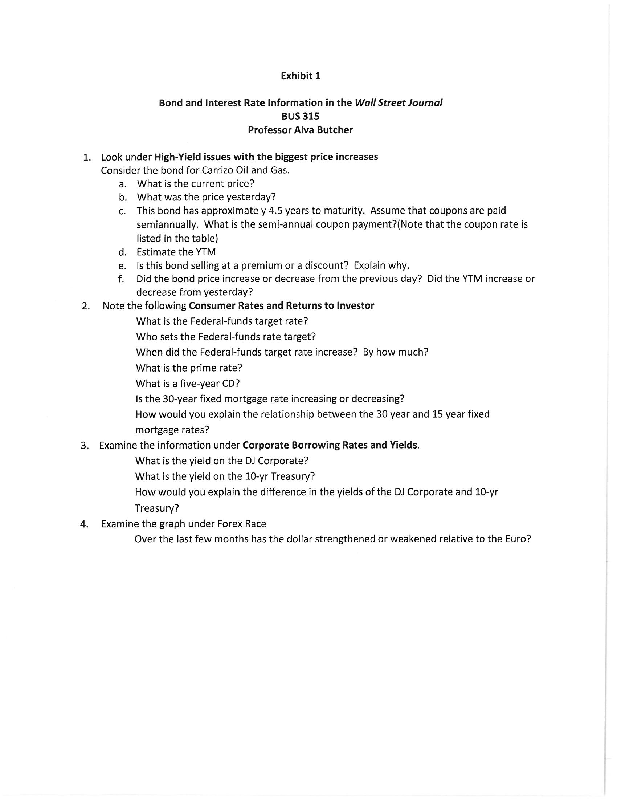
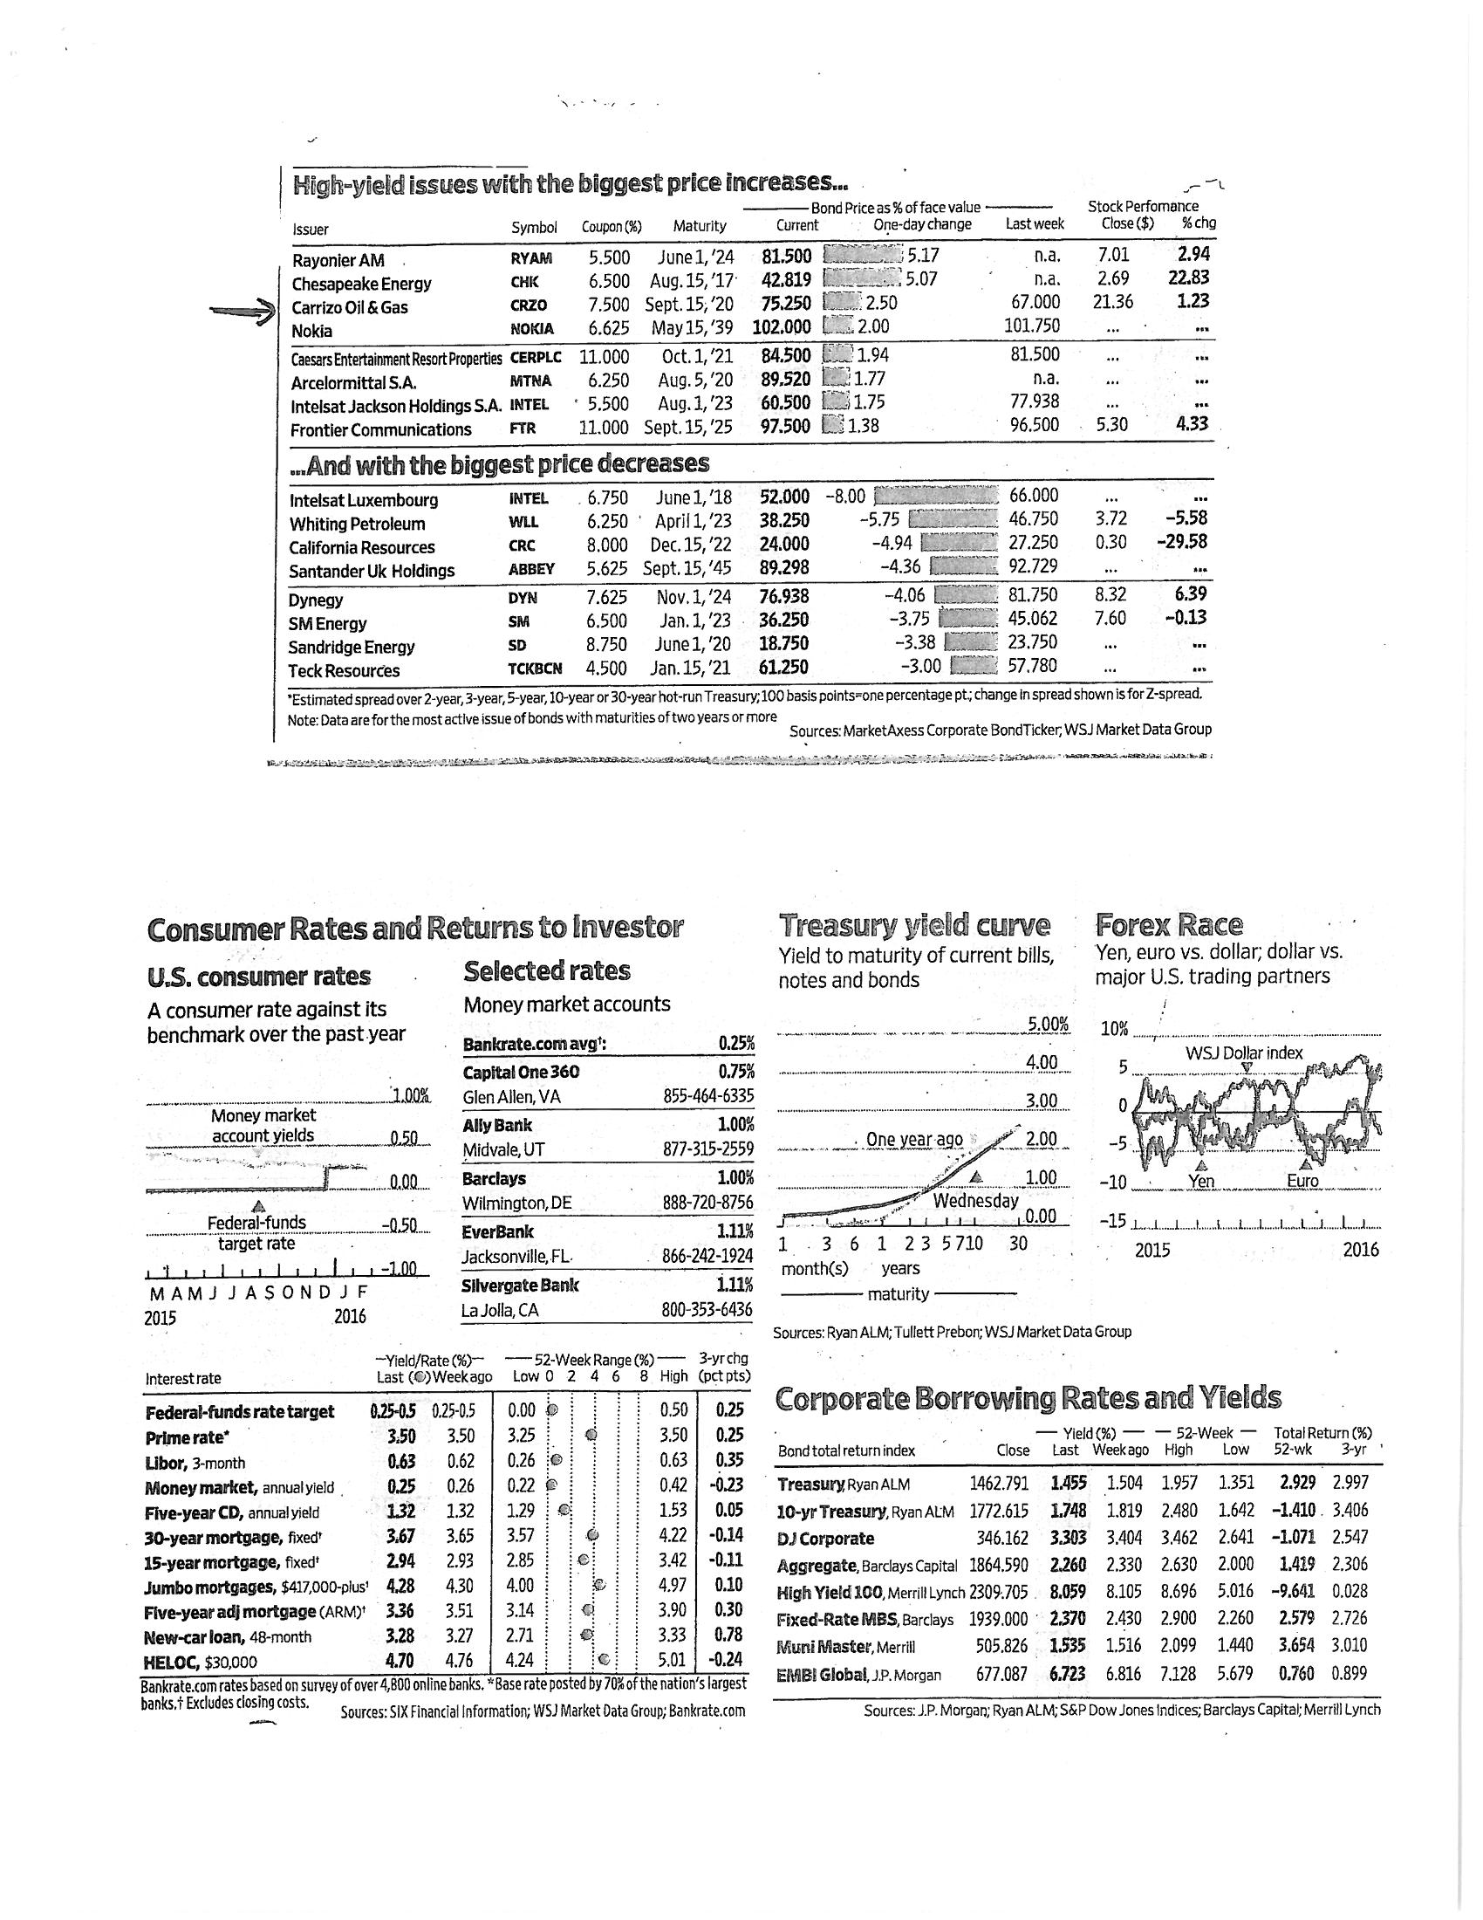

Exhibit 2
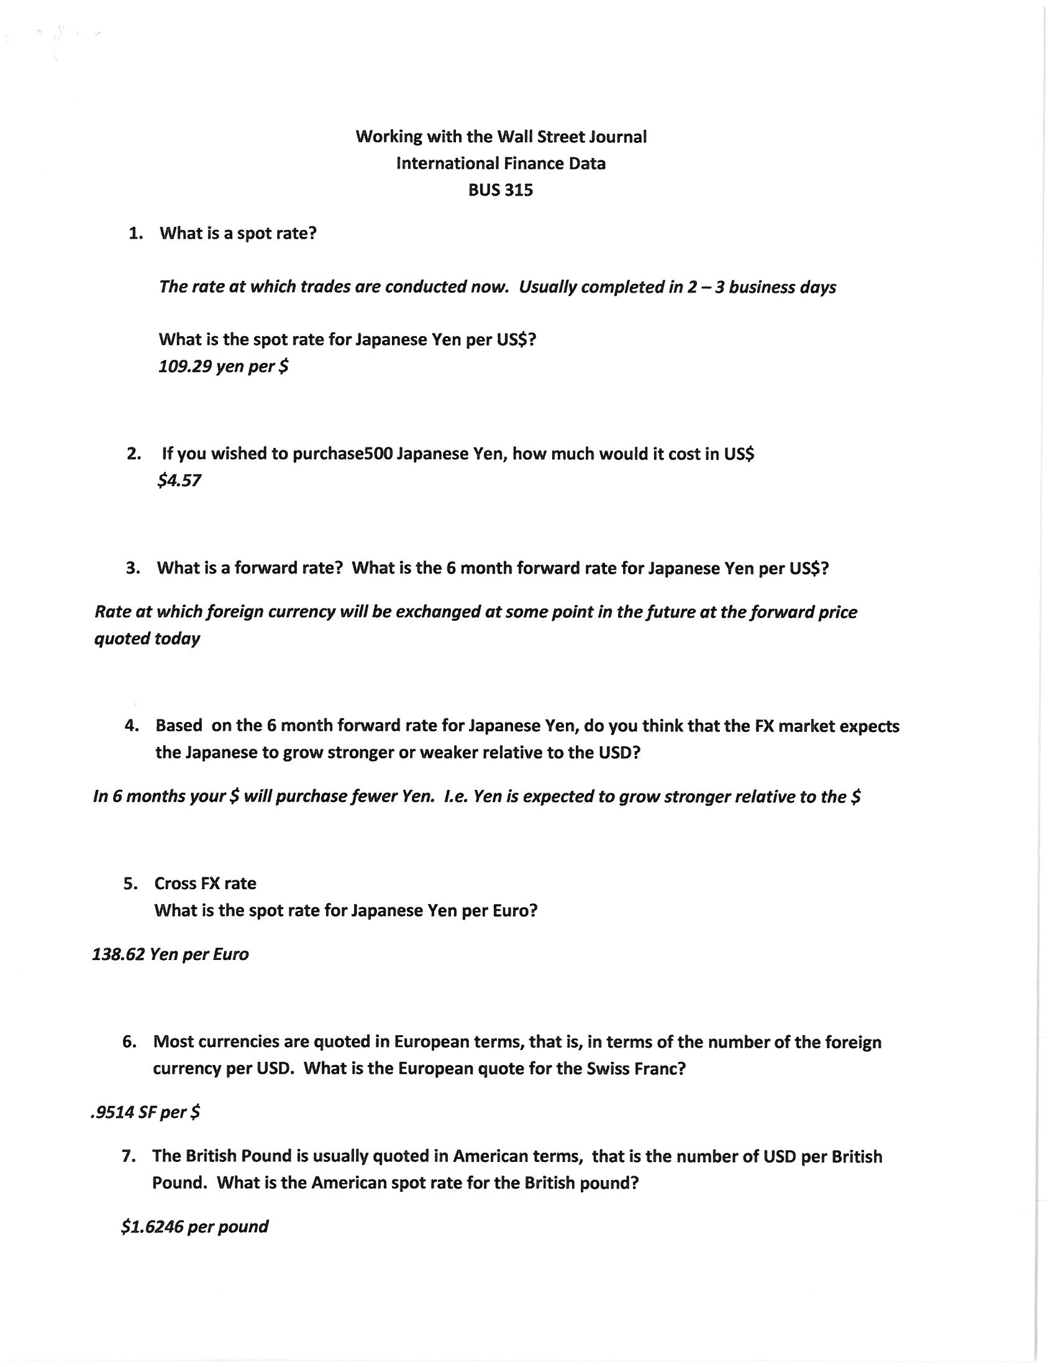
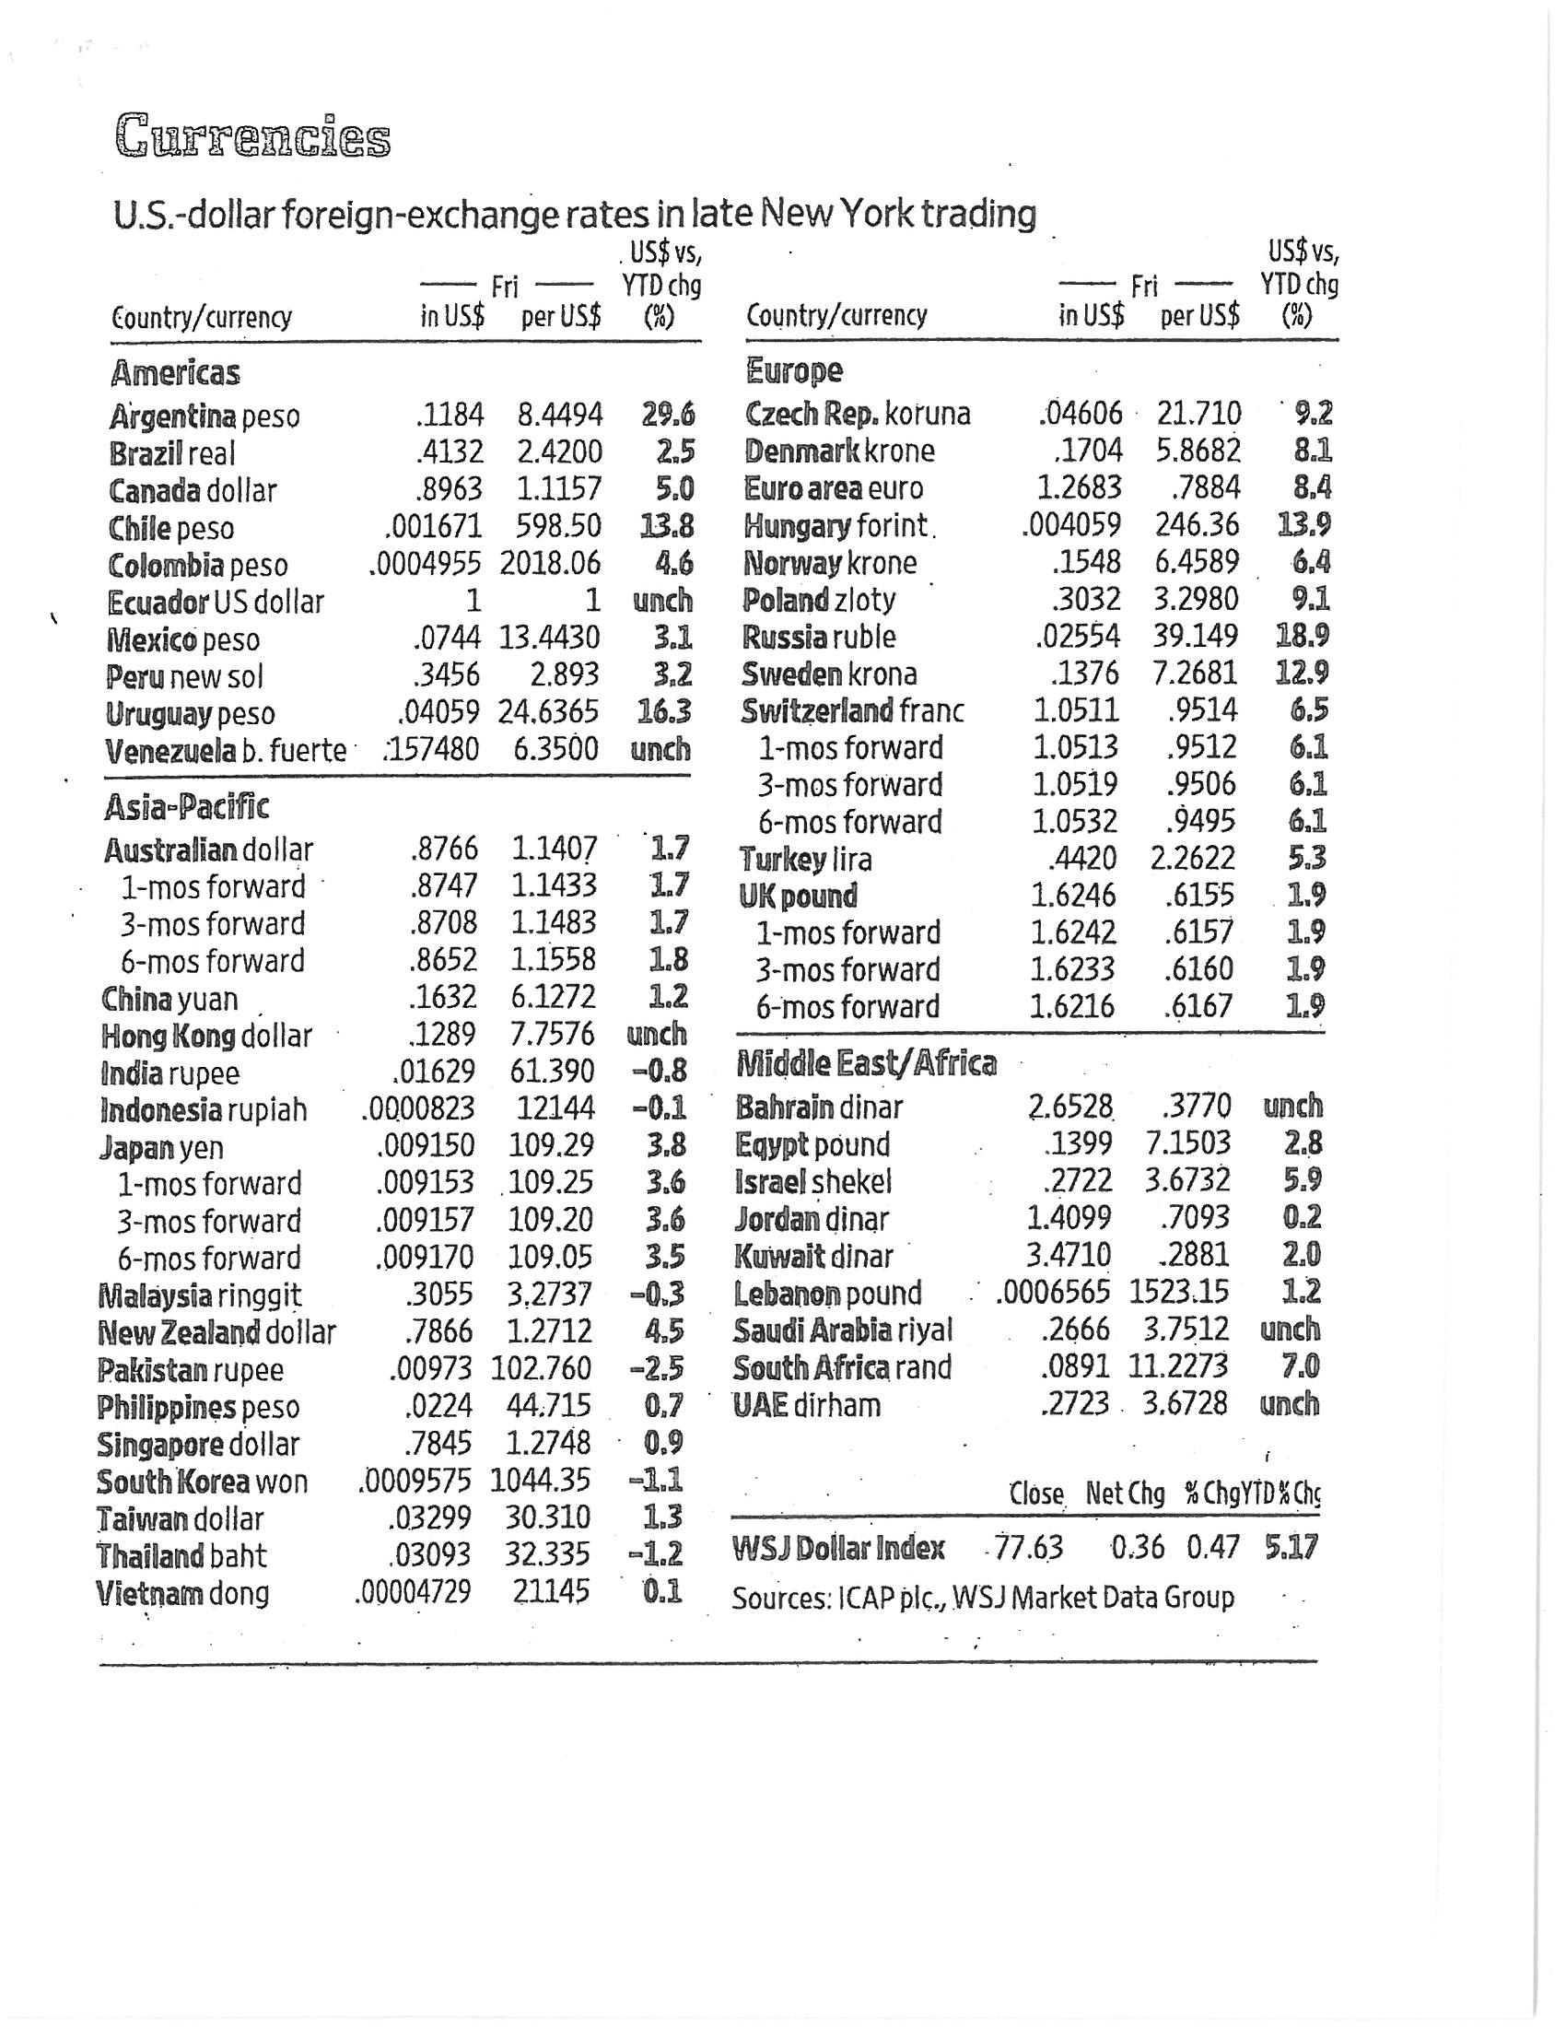

Exhibit 3
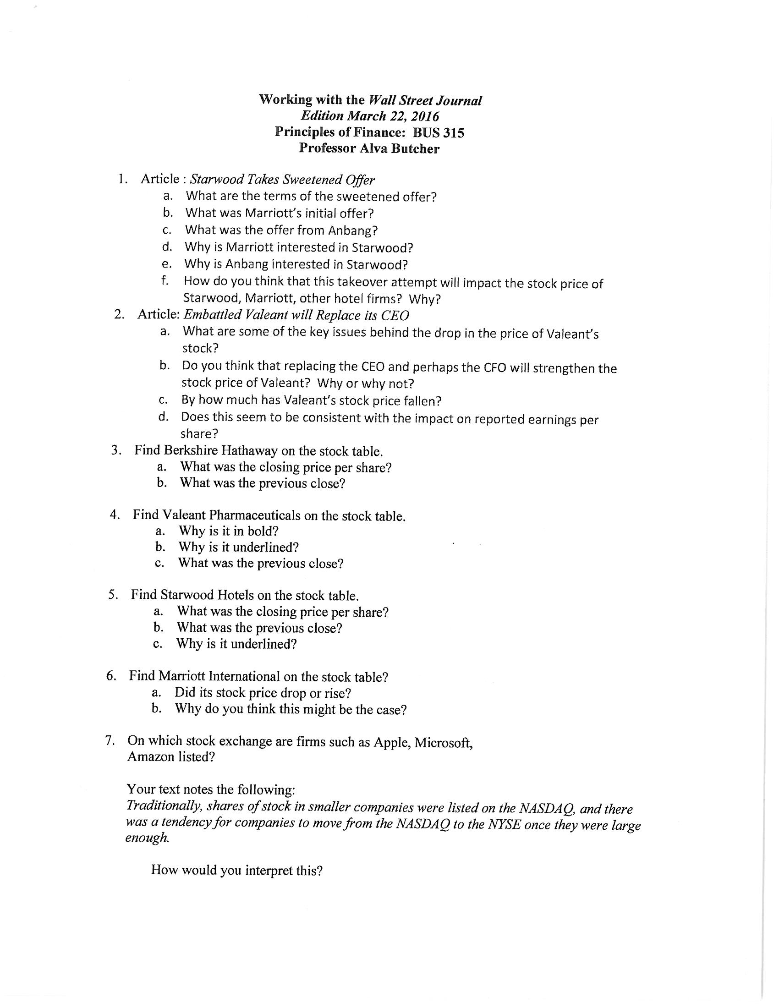
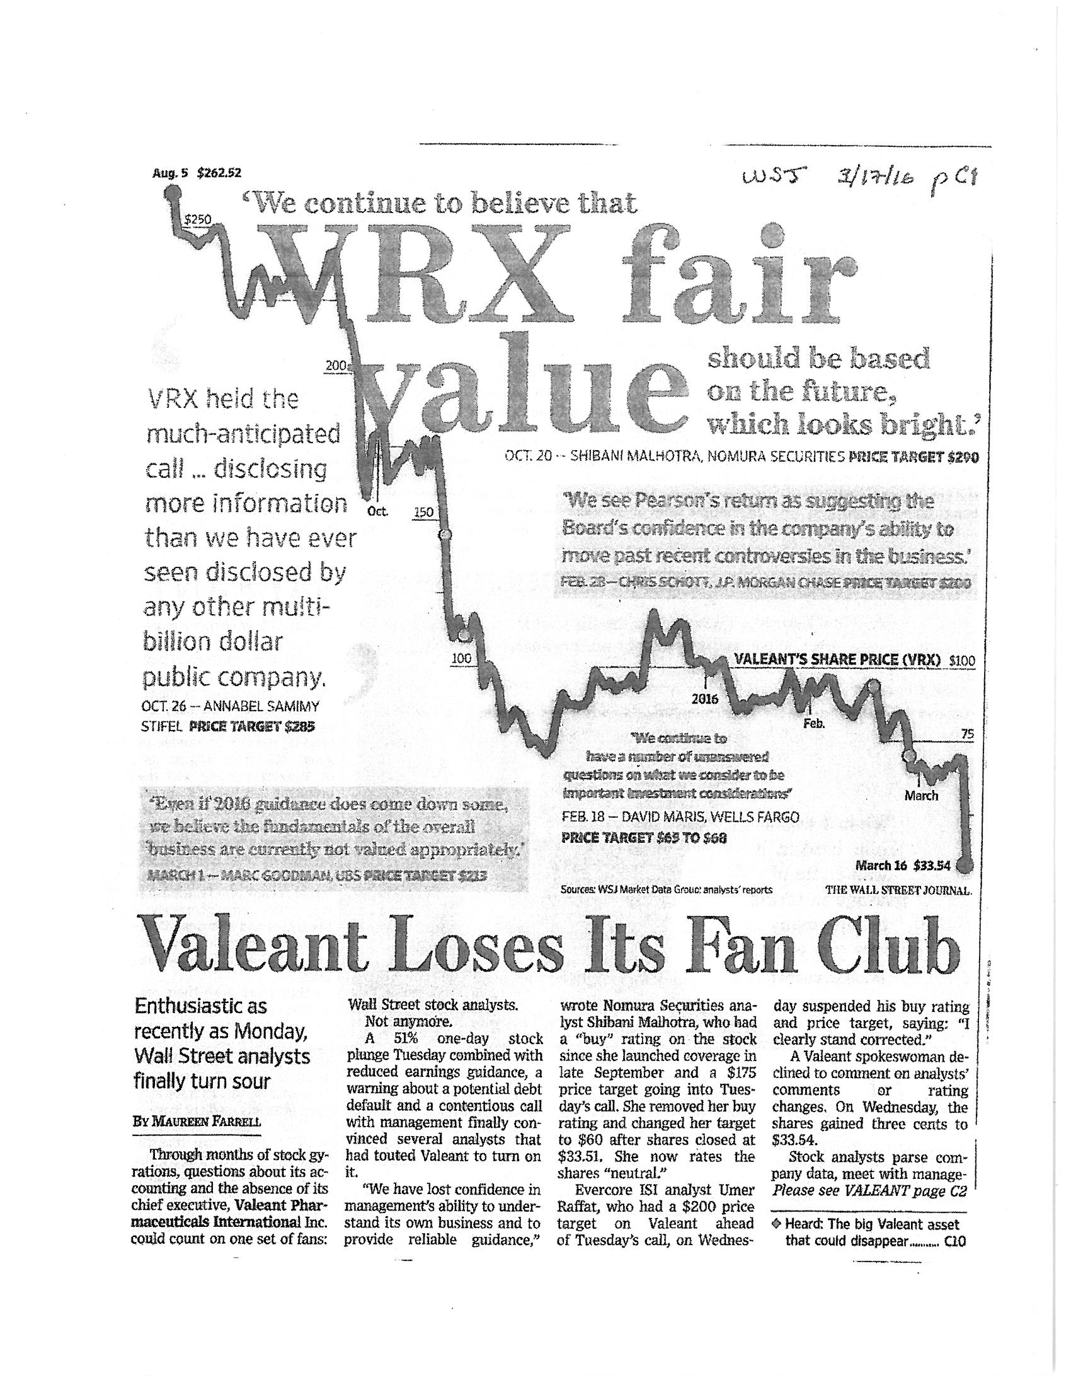
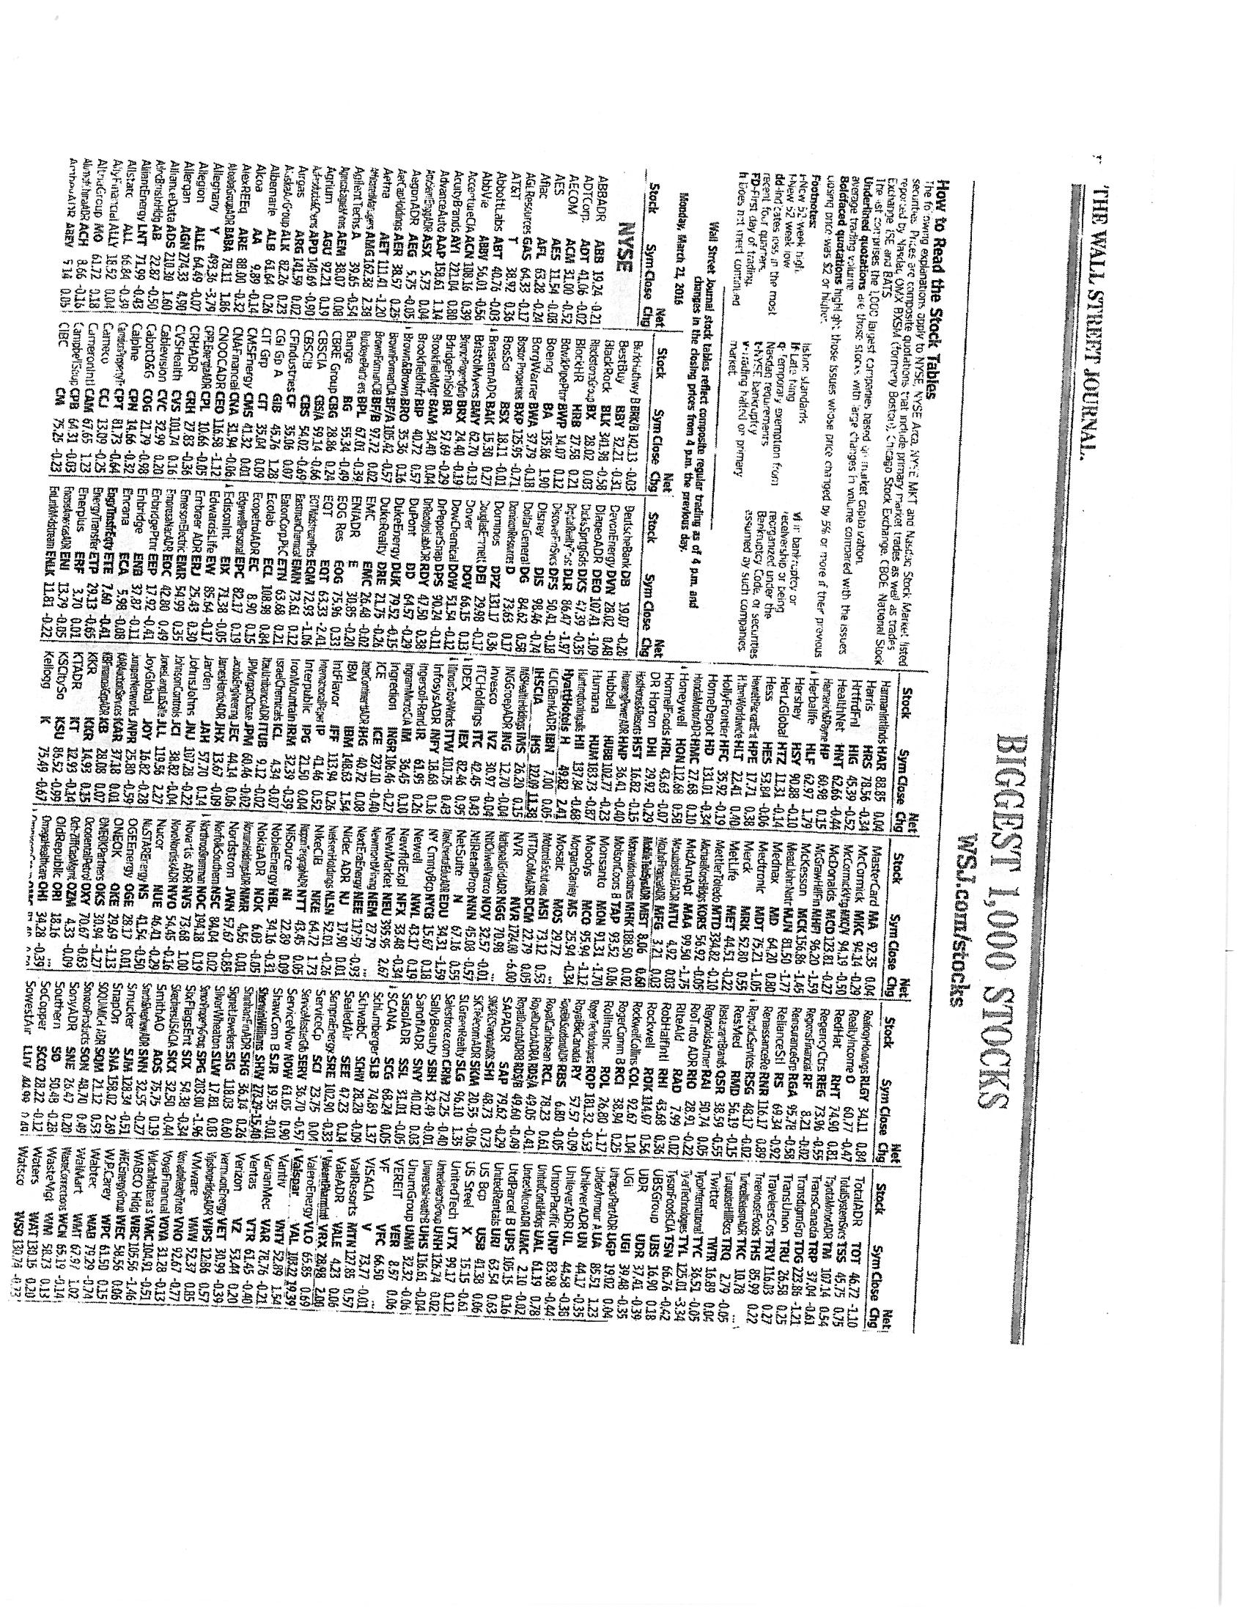

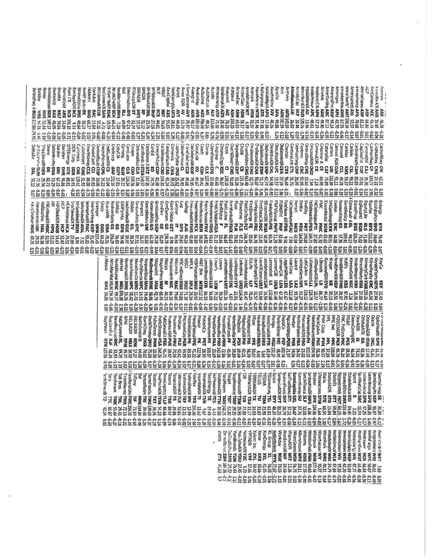

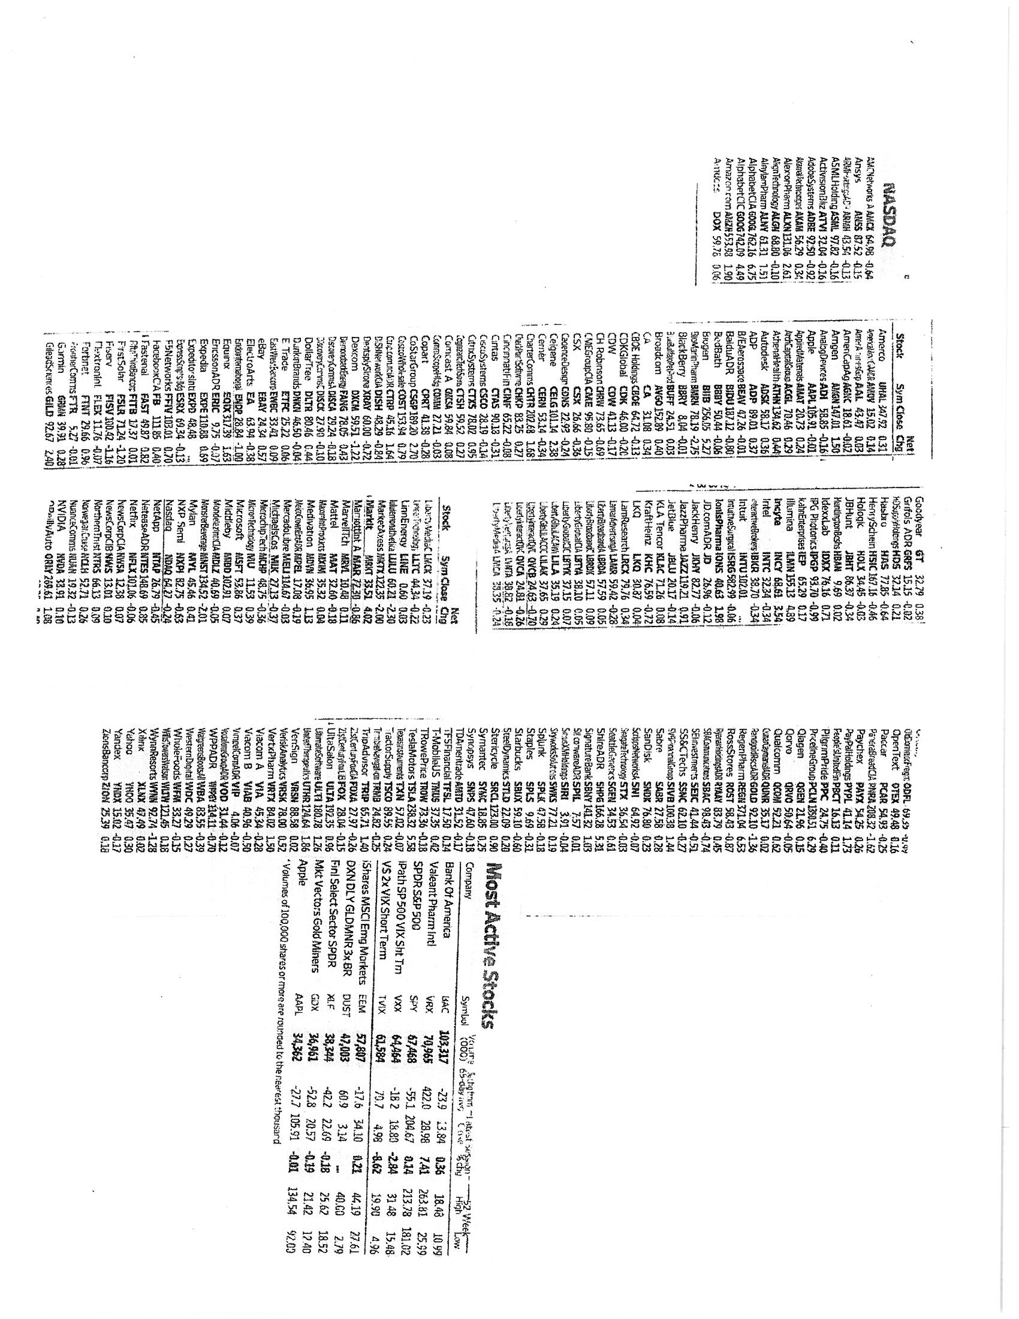

Exhibit 4
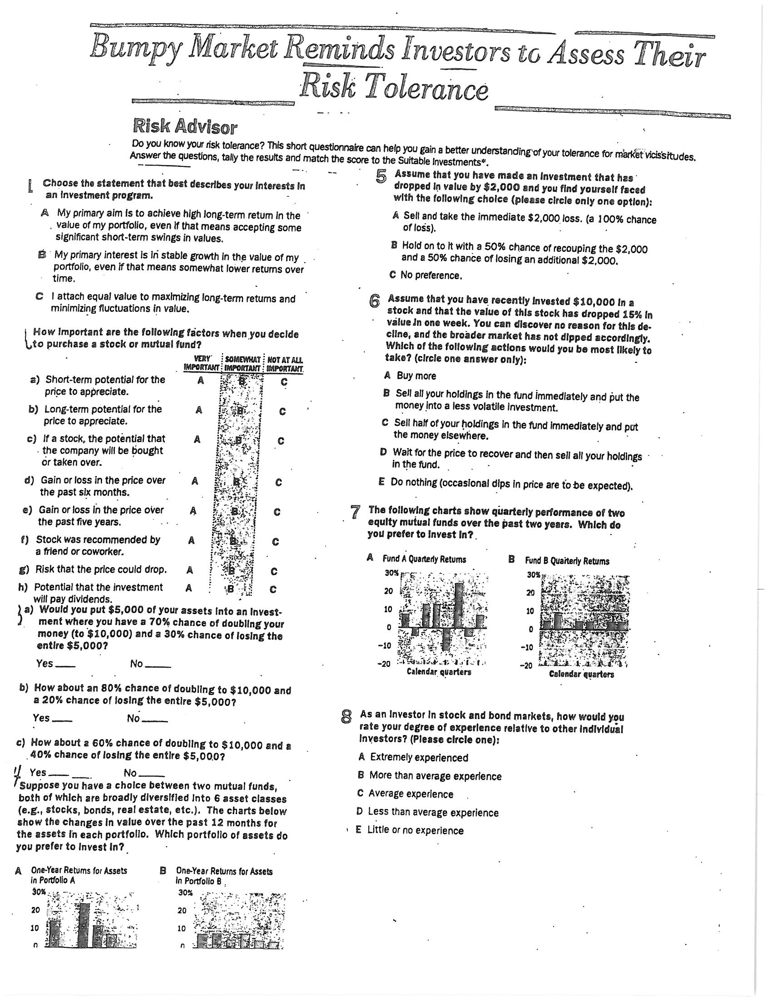
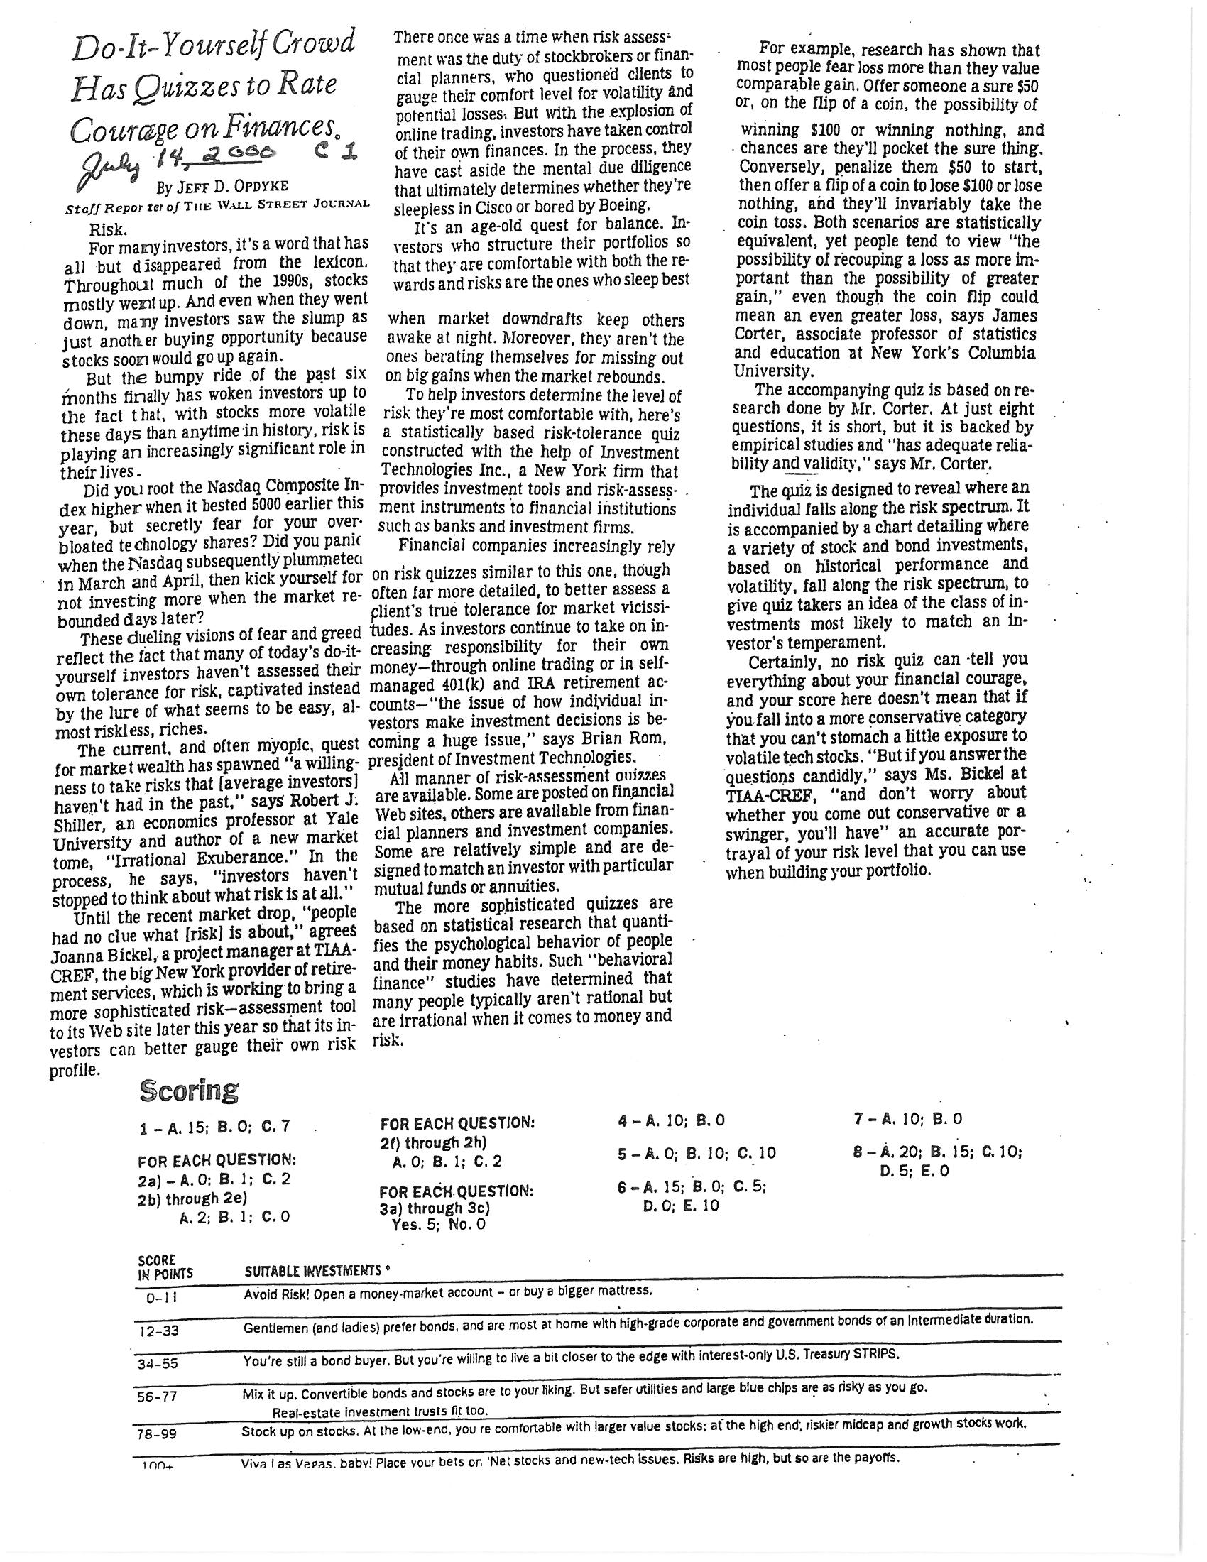

Many students are very conservative in their investment and end up placing a large amount in savings.
This data collection is treated as a separate step in order to ensure that students have the data needed for the regression analysis later in the project.

